Lab - Configure VLANs and Trunking

Topology


Addressing Table
Device | Interface | IP Address | Subnet Mask | Default Gateway
S1 | VLAN 1 | 192.168.1.11 | 255.255.255.0 | N/A
S2 | VLAN 1 | 192.168.1.12 | 255.255.255.0 | N/A
PC-A | NIC | 192.168.10.3 | 255.255.255.0 | 192.168.10.1
PC-B | NIC | 192.168.10.4 | 255.255.255.0 | 192.168.10.1

Objectives
Part 1: Build the Network and Configure Basic Device Settings
Part 2: Create VLANs and Assign Switch Ports
Part 3: Maintain VLAN Port Assignments and the VLAN Database
Part 4: Configure an 802.1Q Trunk between the Switches
Part 5: Delete the VLAN Database

Background / Scenario
Modern switches use virtual local-area networks (VLANs) to improve network performance by separating large Layer 2 broadcast domains into smaller ones. VLANs can also be used as a security measure by controlling which hosts can communicate. In general, VLANs make it easier to design a network to support the goals of an organization.
VLAN trunks are used to span VLANs across multiple devices. Trunks allow the traffic from multiple VLANS to travel over a single link, while keeping the VLAN identification and segmentation intact.
In this lab, you will create VLANs on both switches in the topology, assign VLANs to switch access ports, verify that VLANs are working as expected, and then create a VLAN trunk between the two switches to allow hosts in the same VLAN to communicate through the trunk, regardless of which switch the host is actually attached to.
Note: The switches used with CCNA hands-on labs are Cisco Catalyst 2960s with Cisco IOS Release 15.2(2) (lanbasek9 image). Other routers, switches, and Cisco IOS versions can be used. Depending on the model and Cisco IOS version, the commands available and the output produced might vary from what is shown in the labs. Refer to the Router Interface Summary Table at the end of the lab for the correct interface identifiers.
Note: Ensure that the routers and switches have been erased and have no startup configurations. If you are unsure contact your instructor.

Required Resources
- 2 Switches (Cisco 2960 with Cisco IOS Release 15.2(2) lanbasek9 image or comparable)
- 2 PCs (Windows with a terminal emulation program, such as Tera Term)
- Console cables to configure the Cisco IOS devices via the console ports
- Ethernet cables as shown in the topology

Instructions

Build the Network and Configure Basic Device Settings
In Part 1, you will set up the network topology and configure basic settings on the PC hosts and switches.

Cable the network as shown in the topology.
Attach the devices as shown in the topology diagram, and cable as necessary.
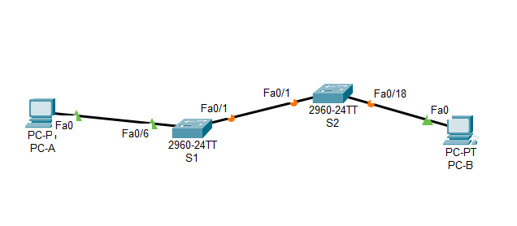
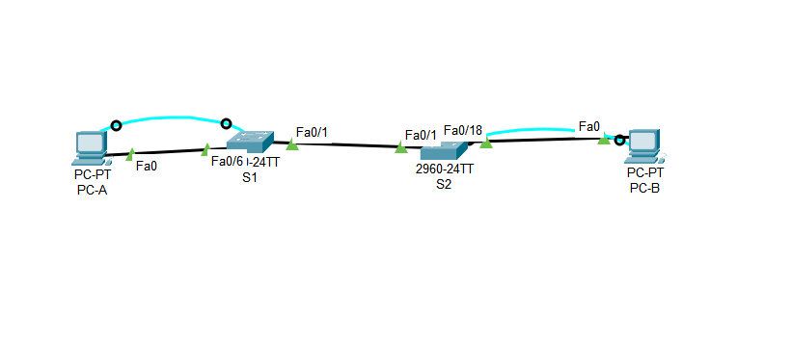

Configure basic settings for each switch.
      - Console into the switch and enable privileged EXEC mode.
Open configuration window
      - Enter configuration mode.
      - Assign a device name to the switch.
S1 | 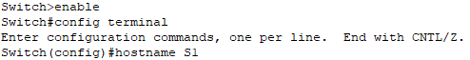  Switch>enable  Switch#config terminal  Switch(config)#hostname S1
S2 | 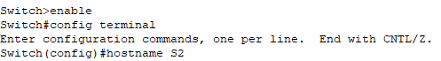  Switch>enable  Switch#config terminal  Switch(config)#hostname S2

      - Disable DNS lookup to prevent the router from attempting to translate incorrectly entered commands as though they were host names.
S1 | S1(config)#no ip domain-lookup
S2 | S2(config)#no ip domain-lookup

      - Assign class as the privileged EXEC encrypted password.
S1 | S1(config)#enable secret class
S2 | S2(config)#enable secret class

      - Assign cisco as the console password and enable login.
S1 | 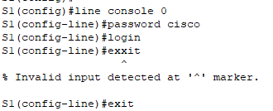  S1(config)#line console 0  S1(config-line)#password cisco  S1(config-line)#login  S1(config-line)#exit
S2 | 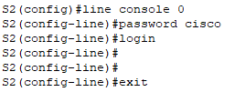  S2(config)#line console 0  S2(config-line)#password cisco  S2(config-line)#login  S2(config-line)#exit

      - Assign cisco as the vty password and enable login.
S1 | 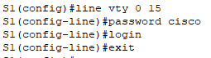  S1(config)#line vty 0 15  S1(config-line)#password cisco  S1(config-line)#login  S1(config-line)#exit
S2 | 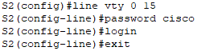  S2(config)#line vty 0 15  S2(config-line)#password cisco  S2(config-line)#login  S2(config-line)#exit

      - Encrypt the plaintext passwords.
S1 | S1(config)#service password-encryption
S2 | S2(config)#service password-encryption

      - Create a banner that warns anyone accessing the device that unauthorized access is prohibited.
S1 | S1(config)#banner motd $ Unauthorized Access is Prohibited!!! $
S2 | S2(config)#banner motd $ Unauthorized Access is Prohibited!!! $

      - Configure the IP address listed in the Addressing Table for VLAN 1 on the switch.
S1 | 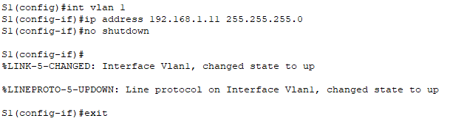  S1(config)#int vlan 1  S1(config-if)#ip address 192.168.1.11 255.255.255.0  S1(config-if)#no shutdown  S1(config-if)#exit
S2 | 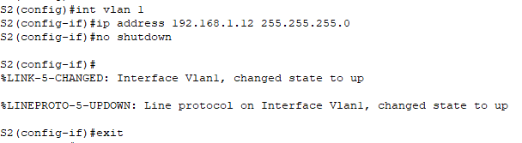  S2(config)#int vlan 1  S2(config-if)#ip address 192.168.1.12 255.255.255.0  S2(config-if)#no shutdown  S2(config-if)#exit

      - Shut down all interfaces that will not be used.
S1 | 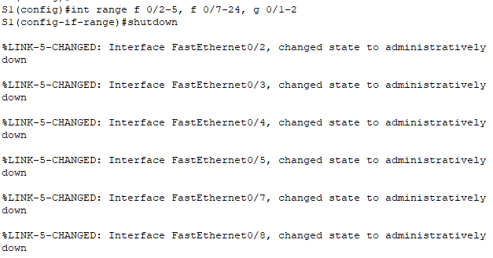  S1(config)#int range f 0/2-5, f 0/7-24, g 0/1-2  S1(config-if-range)#shutdown
S2 | 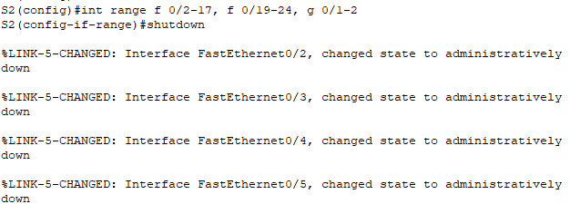  S2(config)#int range f 0/2-17, f 0/19-24, g 0/1-2  S2(config-if-range)#shutdown

      - Set the clock on the switch.
S1 | 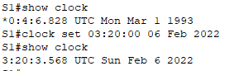  S1#show clock  S1#clock set 03:20:00 06 Feb 2022  S1#show clock
S2 | 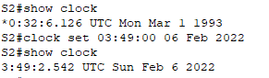  S2#show clock  S2#clock set 03:49:00 06 Feb 2022  S2#show clock

      - Save the running configuration to the startup configuration file.
S1 | 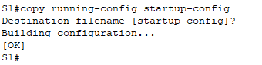  S1#copy running-config startup-config  Destination filename [startup-config]? Enter
S2 | 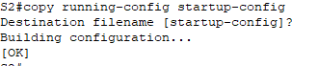  S2#copy running-config startup-config  Destination filename [startup-config]? Enter

Close configuration window

Configure PC hosts.
Refer to the Addressing Table for PC host address information.
PC-A | 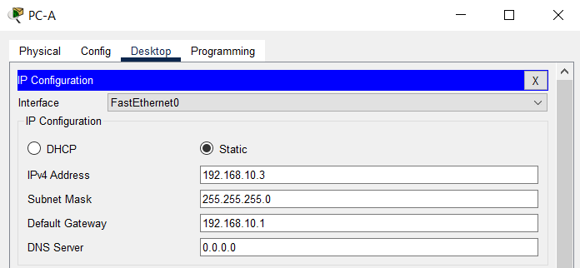
PC-B | 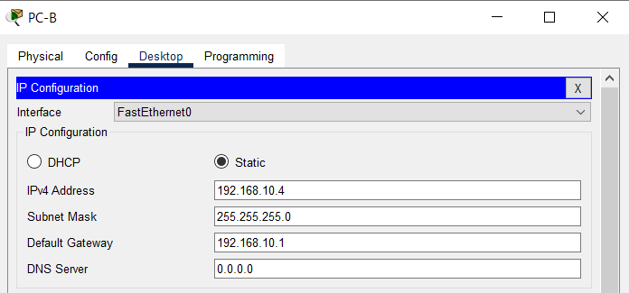

Test connectivity.
Verify that the PC hosts can ping one another.
Note: It may be necessary to disable the PCs firewall to ping between PCs.

Questions:
Can PC-A ping PC-B?
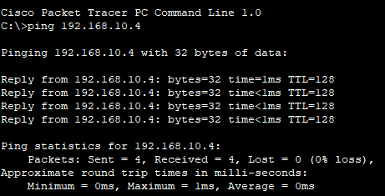
Can,Ping successfully.Because they are in the same subnet.

Can PC-A ping S1?
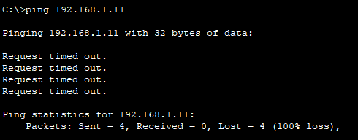
Cant,Ping Fail,Because they are in the different subnet.

Can PC-B ping S2?
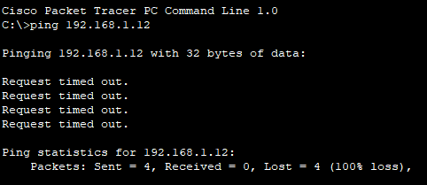
Cant,Ping Fail,Because they are in the different subnet.

Open configuration window

Can S1 ping S2?
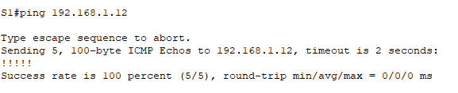
Can,Ping successfully.Because they are in the same subnet.
If you answered no to any of the above questions, why were the pings unsuccessful?
Because they are in different subnets. If the ping is to succeed, the devices needs to be in the same subnet.

Type your answers here.
Close configuration window

Create VLANs and Assign Switch Ports
In Part 2, you will create Management, Operations, Parking_Lot, and Native VLANs on both switches. You will then assign the VLANs to the appropriate interface. The show vlan command is used to verify your configuration settings.

Create VLANs on the switches.
Open configuration window
      - Create the VLANs on S1.
S1(config)# vlan 10
S1(config-vlan)# name Operations
S1(config-vlan)# vlan 20
S1(config-vlan)# name Parking_Lot
S1(config-vlan)# vlan 99
S1(config-vlan)# name Management
S1(config-vlan)# vlan 1000
S1(config-vlan)# name Native
S1(config-vlan)# end
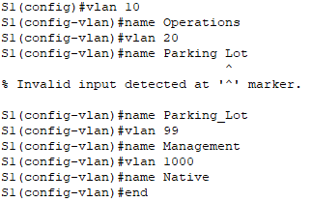
S1(config)#vlan 10
S1(config-vlan)#name Operations
S1(config-vlan)#vlan 20
S1(config-vlan)#name Parking_Lot
S1(config-vlan)#vlan 99
S1(config-vlan)#name Management
S1(config-vlan)#vlan 1000
S1(config-vlan)#name Native
S1(config-vlan)#end

      - Create the same VLANs on S2.
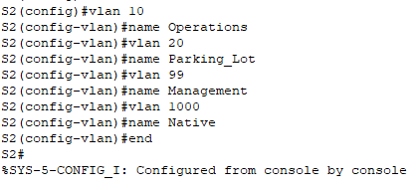
S2(config)#vlan 10
S2(config-vlan)#name Operations
S2(config-vlan)#vlan 20
S2(config-vlan)#name Parking_Lot
S2(config-vlan)#vlan 99
S2(config-vlan)#name Management
S2(config-vlan)#vlan 1000
S2(config-vlan)#name Native
S2(config-vlan)#end

      - Issue the show vlan brief command to view the list of VLANs on S1.
S1# show vlan brief

VLAN Name Status Ports
---- -------------------------------- --------- -------------------------------
1 default active Fa0/1, Fa0/2, Fa0/3, Fa0/4
Fa0/5, Fa0/6, Fa0/7, Fa0/8
Fa0/9, Fa0/10, Fa0/11, Fa0/12
Fa0/13, Fa0/14, Fa0/15, Fa0/16
Fa0/17, Fa0/18, Fa0/19, Fa0/20
Fa0/21, Fa0/22, Fa0/23, Fa0/24
Gi0/1, Gi0/2
10 Operations active
20 Parking_Lot active
99 Management active
1000 Native active
1002 fddi-default act/unsup
1003 token-ring-default act/unsup
1004 fddinet-default act/unsup
1005 trnet-default act/unsup

Questions:
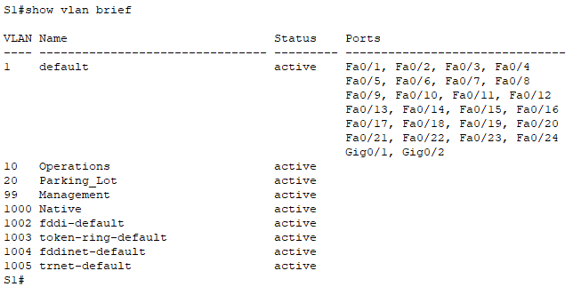

What is the default VLAN?
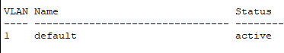
VLAN 1

What ports are assigned to the default VLAN?

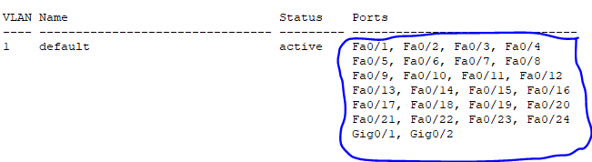
All the ports

Assign VLANs to the correct switch interfaces.
      - Assign VLANs to the interfaces on S1.
        - Assign PC-A to the Operation VLAN.
S1(config)# interface f0/6
S1(config-if)# switchport mode access
S1(config-if)# switchport access vlan 10
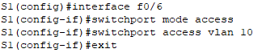
S1(config)#interface f0/6
S1(config-if)#switchport mode access
S1(config-if)#switchport access vlan 10
S1(config-if)#exit

        - Move the switch IP address VLAN 99.
S1(config)# interface vlan 1
S1(config-if)# no ip address
S1(config-if)# interface vlan 99
S1(config-if)# ip address 192.168.1.11 255.255.255.0
S1(config-if)# end
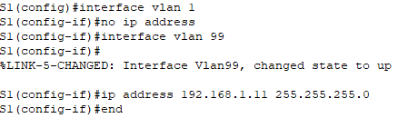
S1(config)#interface vlan 1
S1(config-if)#no ip address
S1(config-if)#interface vlan 99
S1(config-if)#ip address 192.168.1.11 255.255.255.0
S1(config-if)#end

      - Issue the show vlan brief command and verify that the VLANs are assigned to the correct interfaces.
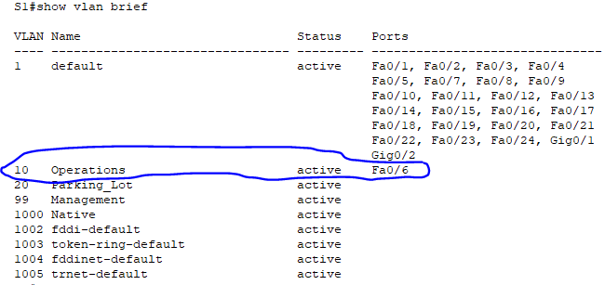

      - Issue the show ip interface brief command.
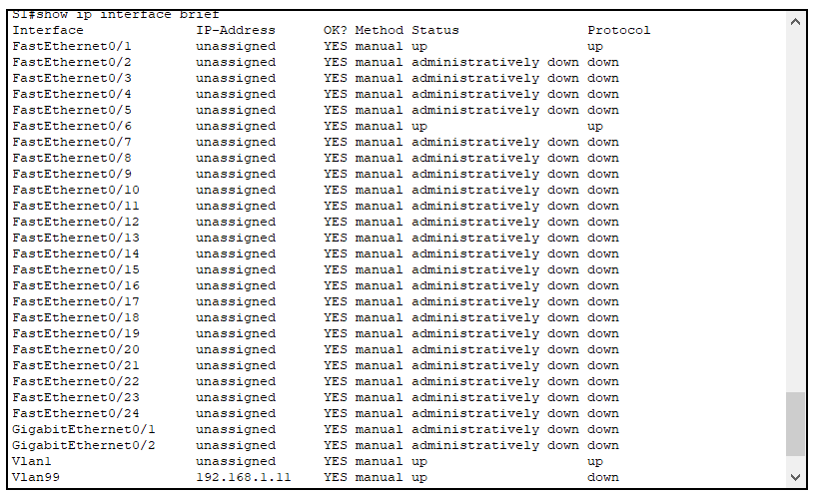

Question:
What is the status of VLAN 99? Explain.
For VLAN 99, the status is up, but the protocol is down. Because VLAN 99 has been created and is in the database, the status is up, but VLAN 99 has not been assigned to an active port, so the protocol is down.

      - Assign PC-B to the Operations VLAN on S2.
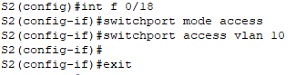
S2(config)#int f 0/18
S2(config-if)#switchport mode access
S2(config-if)#switchport access vlan 10

      - Remove the IP address for VLAN 1 on S2.
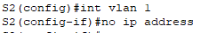
S2(config)#int vlan 1
S2(config-if)#no ip address

      - Configure an IP address for VLAN 99 on S2 according to the Addressing Table.
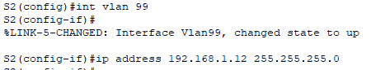
S2(config)#int vlan 99
S2(config-if)#ip address 192.168.1.12 255.255.255.0

      - Use the show vlan brief command to verify that the VLANs are assigned to the correct interfaces.
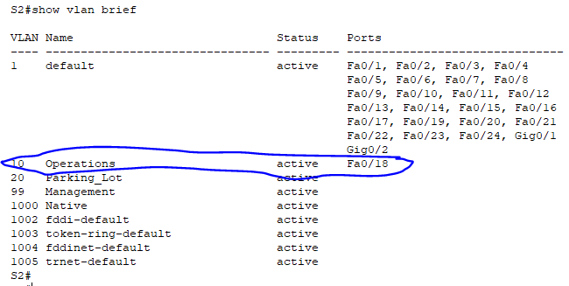

Questions:
Is S1 able to ping S2? Explain.
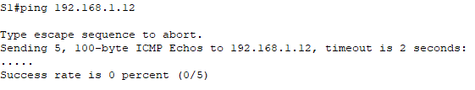
No, the ping failed. Because the IP address assigned to VLAN 99 does not send VLAN 99 traffic through interface F0/1.

Close configuration window
Is PC-A able to ping PC-B? Explain.

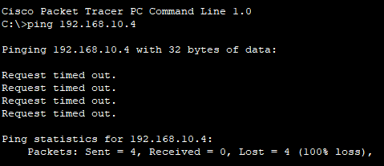
No, the ping failed. Since both PC-A and PC-B have IP addresses assigned to VLAN 10, but interface F0/1 only allows VLAN 1 (the default VLAN), VLAN 10 will not send VLAN 10 traffic through interface F0/1.

Maintain VLAN Port Assignments and the VLAN Database
In Part 3, you will change VLAN assignments to ports and remove VLANs from the VLAN database.

Assign a VLAN to multiple interfaces.
Open configuration window
      - On S1, assign interfaces F0/11 – 24 to VLAN99.
S1(config)# interface range f0/11-24
S1(config-if-range)# switchport mode access
S1(config-if-range)# switchport access vlan 99
S1(config-if-range)# end
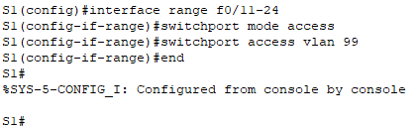
S1(config)#interface range f0/11-24
S1(config-if-range)#switchport mode access
S1(config-if-range)#switchport access vlan 99
S1(config-if-range)#end

      - Issue the show vlan brief command to verify VLAN assignments.
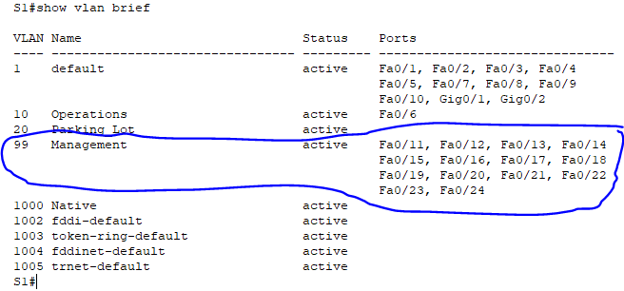

      - Reassign F0/11 and F0/21 to VLAN 10.
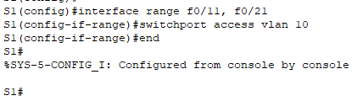
S1(config)#interface range f0/11, f0/21
S1(config-if-range)#switchport access vlan 10
S1(config-if-range)#end

      - Verify that VLAN assignments are correct.
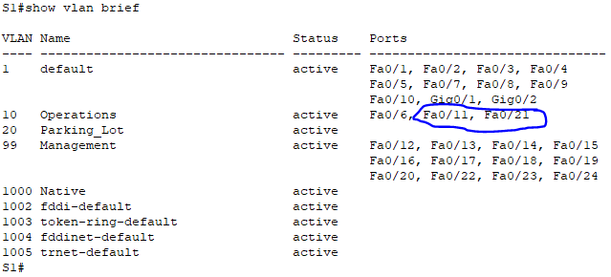

Remove a VLAN assignment from an interface.
      - Use the no switchport access vlan command to remove the VLAN 99 assignment to F0/24.
S1(config)# interface f0/24
S1(config-if)# no switchport access vlan
S1(config-if)# end
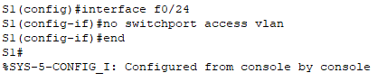
S1(config)#interface f0/24
S1(config-if)#no switchport access vlan
S1(config-if)#end

      - Verify that the VLAN change was made.

Question:
Which VLAN is F0/24 now associated with?

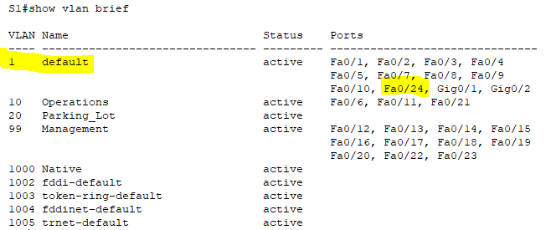
VLAN 1(Default VLAN)

Remove a VLAN ID from the VLAN database.
      - Add VLAN 30 to interface F0/24 without issuing the global VLAN command.
S1(config)# interface f0/24
S1(config-if)# switchport access vlan 30
% Access VLAN does not exist. Creating vlan 30
Note: Current switch technology no longer requires that the vlan command be issued to add a VLAN to the database. By assigning an unknown VLAN to a port, the VLAN will be created and added to the VLAN database.
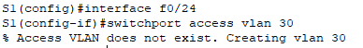
S1(config)#interface f0/24
S1(config-if)#switchport access vlan 30

      - Verify that the new VLAN is displayed in the VLAN table.

Question:
What is the default name of VLAN 30?
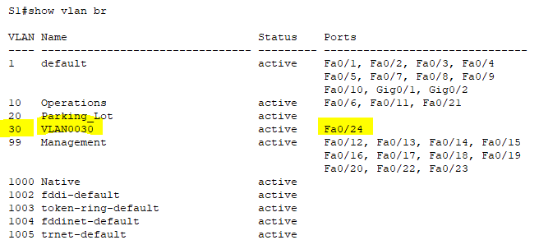
VLAN0030

      - Use the no vlan 30 command to remove VLAN 30 from the VLAN database.
S1(config)# no vlan 30
S1(config)# end
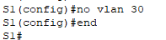
S1(config)#no vlan 30
S1(config)#end

      - Issue the show vlan brief command. F0/24 was assigned to VLAN 30.

Question:
After deleting VLAN 30 from the VLAN database, what VLAN is port F0/24 assigned to? What happens to the traffic destined to the host attached to F0/24?
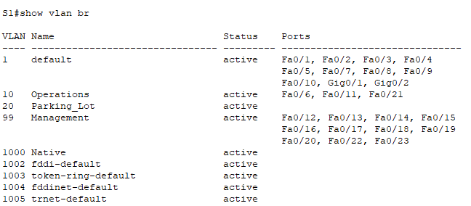
After deleting VLAN 30 from the VLAN database, what VLAN is port F0/24 assigned to?
After removing VLAN 30 from the VLAN database, port F0/24 is still assigned to VLAN 30. So if you delete VLAN 30, port F0/24 will become inactive, so you won't see F0/24 in any existing VLAN database.

What happens to the traffic destined to the host attached to F0/24?
The F0/24 port will not carry any traffic because the port is inactive.

      - Issue the no switchport access vlan command on interface F0/24.
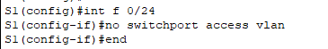
S1(config)#int f 0/24
S1(config-if)#no switchport access vlan
S1(config-if)#end

      - Issue the show vlan brief command to determine the VLAN assignment for F0/24.

Questions:
To which VLAN is F0/24 assigned?
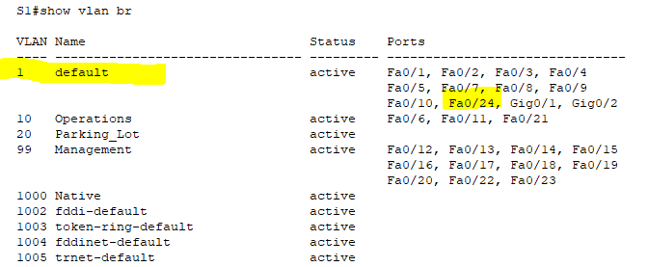
VLAN 1(Default VLAN)

Note: Before removing a VLAN from the database, it is recommended that you reassign all the ports assigned to that VLAN.
Why should you reassign a port to another VLAN before removing the VLAN from the VLAN database?

The port interface assigned to the VLAN removed from the VLAN database becomes inactive, so the port interface will not carry any traffic. In addition to this, port interfaces do not appear in the VLAN database.

Configure an 802.1Q Trunk Between the Switches
In Part 4, you will configure interface F0/1 to use the Dynamic Trunking Protocol (DTP) to allow it to negotiate the trunk mode. After this has been accomplished and verified, you will disable DTP on interface F0/1 and manually configure it as a trunk.

Use DTP to initiate trunking on F0/1.
The default DTP mode of a 2960 switch port is dynamic auto. This allows the interface to convert the link to a trunk if the neighboring interface is set to trunk or dynamic desirable mode.
Open configuration window
      - Set F0/1 on S1 to negotiate trunk mode.
S1(config)# interface f0/1
S1(config-if)# switchport mode dynamic desirable
Sep 19 02:51:47.257: %LINEPROTO-5-UPDOWN: Line protocol on Interface FastEthernet0/1, changed state to up
Sep 19 02:51:47.291: %LINEPROTO-5-UPDOWN: Line protocol on Interface Vlan99, changed state to up
You should also receive link status messages on S2.
S2#
Sep 19 02:42:19.424: %LINK-3-UPDOWN: Interface FastEthernet0/1, changed state to up
Sep 19 02:42:21.454: %LINEPROTO-5-UPDOWN: Line protocol on Interface Vlan99, changed state to up
Sep 19 02:42:22.419: %LINEPROTO-5-UPDOWN: Line protocol on Interface FastEthernet0/1, changed state to up
S1 | 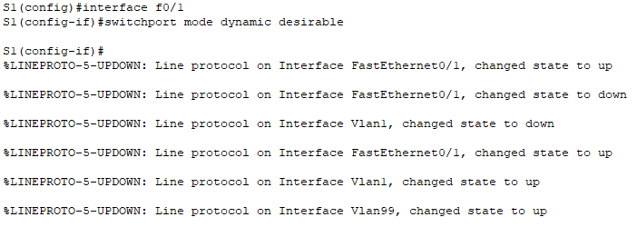
S2 | 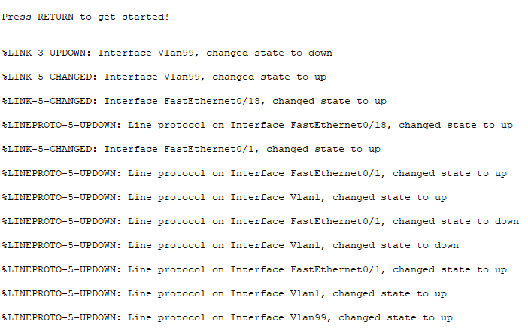

      - Issue the show vlan brief command on S1 and S2. Interface F0/1 is no longer assigned to VLAN 1. Trunked interfaces are not listed in the VLAN table.
S1 | 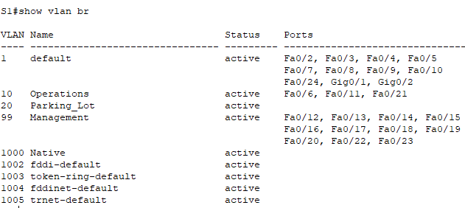
S2 | 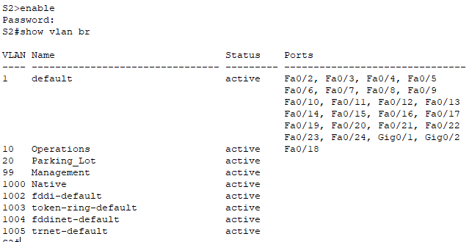

      - Issue the show interfaces trunk command to view trunked interfaces. Notice that the mode on S1 is set to desirable, and the mode on S2 is set to auto.
S1# show interfaces trunk

S2# show interfaces trunk
Note: By default, all VLANs are allowed on a trunk. The switchport trunk command allows you to control what VLANs have access to the trunk. For this lab, keep the default settings which allows all VLANs to traverse F0/1.
Close configuration window
S1 | 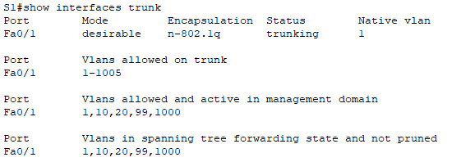
S2 | 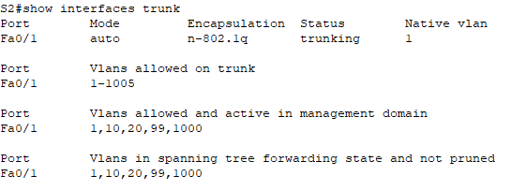

      - Verify that VLAN traffic is traveling over trunk interface F0/1.

Questions:
Can S1 ping S2?
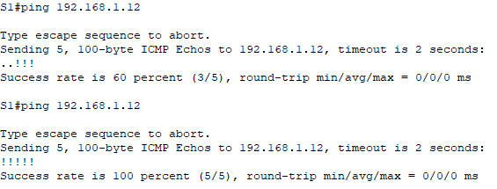
Can,Ping Successfully

Can PC-A ping PC-B?
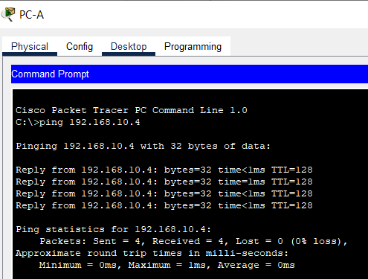
Can,Ping Successfully

Can PC-A ping S1?
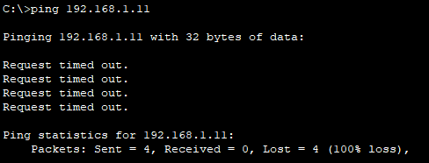
Cant,Ping Fail

Can PC-B ping S2?
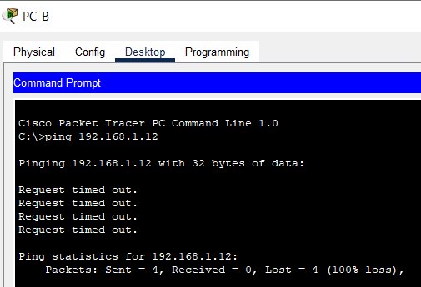
Cant,Ping Fail

If you answered no to any of the above questions, explain below.

Because S1 and S2 are in the VLAN 99 and they are in different subnet address,PC-A and PC-B are in the VLAN 10 and they are in different subnet address.

Manually configure trunk interface F0/1.
The switchport mode trunk command is used to manually configure a port as a trunk. This command should be issued on both ends of the link.
      - Change the switchport mode on interface F0/1 to force trunking. Make sure to do this on both switches.
Open configuration window
S1(config)# interface f0/1
S1(config-if)# switchport mode trunk
S1 | 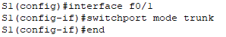
S2 | 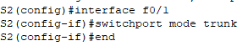

      - Issue the show interfaces trunk command to view the trunk mode. Notice that the mode changed from desirable to on.
S2# show interfaces trunk
S1 | 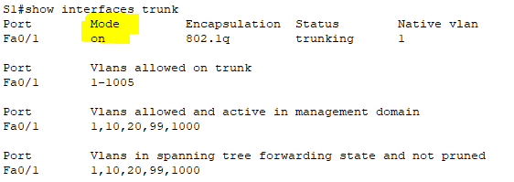
S2 | 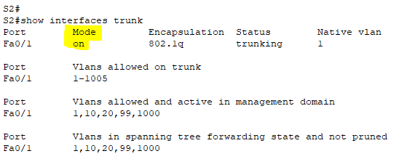

      - Modify the trunk configuration on both switches by changing the native VLAN from VLAN 1 to VLAN 1000.
S1(config)# interface f0/1
S1(config-if)# switchport trunk native vlan 1000
S1 | 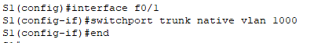
S2 | 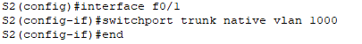

      - Issue the show interfaces trunk command to view the trunk. Notice the Native VLAN information is updated.
S2# show interfaces trunk

Questions:
S1 | 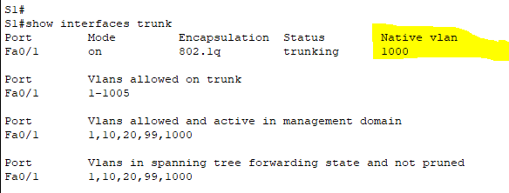
S2 | 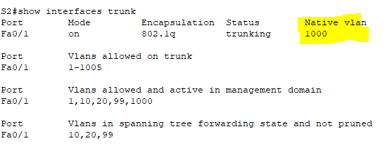

Why might you want to manually configure an interface to trunk mode instead of using DTP?
The switch port mode trunk command ensures that the port will be a trunk regardless of the device type. Because not all devices use DTP.

Why might you want to change the native VLAN on a trunk?
Since the default VLAN (VLAN 1) is used as a native VLAN, there is a security risk and there is a risk of information leakage.
re.
Close configuration window

Delete the VLAN Database [Save your file as version 2 to using “Save As” button , then only do the following]
In Part 5, you will delete the VLAN Database from the switch. It is necessary to do this when initializing a switch back to its default settings.

Determine if the VLAN database exists.
Open configuration window
Issue the show flash command to determine if a vlan.dat file exists in flash.
S1# show flash:
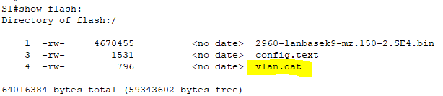

Note: If there is a vlan.dat file located in flash, then the VLAN database does not contain its default settings.

Delete the VLAN database.
      - Issue the delete vlan.dat command to delete the vlan.dat file from flash and reset the VLAN database back to its default settings. You will be prompted twice to confirm that you want to delete the vlan.dat file. Press Enter both times.
S1# delete vlan.dat
Delete filename [vlan.dat]?
Delete flash:/vlan.dat? [confirm]
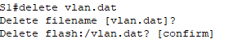

      - Issue the show flash command to verify that the vlan.dat file has been deleted.
S1# show flash:

Question:
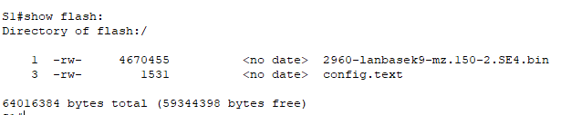

To initialize a switch back to its default settings, what other commands are needed?
erase startup-config command

Close configuration window

Reflection Questions
  - What is needed to allow hosts on VLAN 10 to communicate to hosts on VLAN 99?
We must use either a router or a layer 3 switch or device.

  - What are some primary benefits that an organization can receive through effective use of VLANs?
- Better Security
- Cost Savings
- Higher performance because it reduce the broadcast domain
- Broadcast storm mitigation

Type your answers here.
End of Document

